

VIT BHOPAL UNIVERSITY

School of Computing Science and Engineering

Bhopal-Indore Highway, Kothrikalan, Sehore

Madhya Pradesh - 466114

CSA4008 - APPLIED MACHINE LEARNING

REG.NO : 23BAI10165

NMAE : Suyash Soni

BRANCH : CSE – AI & ML

SEMESTER: Fall Semester 2025-26

INDEX

|  |  |  |  |
| --- | --- | --- | --- |
| Ex.NO | DATE | EXPERIMENT NAME | PAGE NO. |
|  |  | **Implement Decision Tree learning** |  |
|  |  | **Implement Logistic Regression** |  |
|  |  | **Implement classification using Multilayer perceptron** |  |
|  |  | **Implement classification using Multilayer perceptron** |  |
|  |  | **Implement Adaboost Algorithm** |  |
|  |  | **Implement Bagging using Random Forests** |  |
|  |  | **Implement K-means Clustering to Find Natural Patterns in Data** |  |
|  |  | **Implement Principle Component Analysis for Dimensionality Reduction** |  |
|  |  | **Evaluating ML algorithm with balanced and unbalanced datasets** |  |
|  |  | **Evaluating ML algorithm with balanced and unbalanced datasets** |  |

|  |  |
| --- | --- |
| **EXP.NO: 02** | **Implement Logistic Regression** |
| **DATE:** |

**AIM : To implement and evaluate a logistic regression model for predicting stock price direction (up/down) using historical stock market data and analyze model performance using various evaluation metrics and visualization techniques.**

**PROCEDURE**

**Logistic Regression**

Logistic regression is a statistical method used for binary classification problems. Unlike linear regression, it uses the logistic function (sigmoid) to map any real-valued input to a value between 0 and 1, making it suitable for probability estimation.

Mathematical Foundation:

* Sigmoid Function: σ(z) = 1/(1 + e^(-z))
* Linear Combination: z = β₀ + β₁x₁ + β₂x₂ + ... + βₙxₙ
* Probability: P(y=1|x) = σ(z)

Key Characteristics:

* Output ranges from 0 to 1
* Uses maximum likelihood estimation
* Assumes linear relationship between features and log-odds
* No assumption of normality for features

**Dataset Description**

Source: Stock market historical data Features:

* Date: Trading date
* Close/Last: Closing price
* Volume: Number of shares traded
* Open: Opening price
* High: Highest price of the day
* Low: Lowest price of the day

Dataset Statistics:

* Total Records: 2,518
* Date Range: 2020-02-28 to [end date]
* Missing Values: None

**Methodology**

4.1 Data Preprocessing

1. Data Type Conversion:
   * Convert date column to datetime format
   * Ensure price columns are numeric (float64)
   * Handle any missing values
2. Feature Engineering:
   * Create target variable: Price_Up (1 if next day's price > current day's price, 0 otherwise)
   * Price_Range = High - Low
   * Price_Change = Close - Open
   * Price_Change_Pct = ((Close - Open) / Open) × 100
   * Volume_MA_5 = 5-day moving average of volume
   * Volume_Above_Avg = Binary indicator for above-average volume

4.2 Model Development

1. Feature Selection:
   * Selected features: Volume, Price_Range, Price_Change, Price_Change_Pct, Volume_MA_5, Volume_Above_Avg
2. Data Splitting:
   * Training set: 80%
   * Test set: 20%
   * Stratified split to maintain class balance
3. Feature Scaling:
   * StandardScaler to normalize features
   * Mean = 0, Standard deviation = 1
4. Model Training:
   * Algorithm: Logistic Regression
   * Solver: Default (liblinear for small datasets)
   * Random state: 42 for reproducibility

**PROGRAM**

import pandas as pd

import numpy as np

import matplotlib.pyplot as plt

import seaborn as sns

from sklearn.model_selection import train_test_split

from sklearn.linear_model import LogisticRegression

from sklearn.preprocessing import StandardScaler

from sklearn.metrics import *

import warnings

warnings.filterwarnings('ignore')

df = pd.read_csv('D:\\ML PROJECTS\\AML lab\\dataset\\HistoricalQuotes.csv')

print("Column names:")

print(df.columns.tolist())

print("\nColumn names with quotes to see spaces:")

for col in df.columns:

print(f"'{col}'")

df.columns = df.columns.str.strip()

df['Close/Last'] = pd.to_numeric(df['Close/Last'].str.replace('$', ''))

df['Open'] = pd.to_numeric(df['Open'].str.replace('$', ''))

df['High'] = pd.to_numeric(df['High'].str.replace('$', ''))

df['Low'] = pd.to_numeric(df['Low'].str.replace('$', ''))

df['Date'] = pd.to_datetime(df['Date'])

def clean_price_column(column):

if column.dtype == 'object':

return pd.to_numeric(column.astype(str).str.replace('$', '').str.replace(',', ''))

else:

return column

df['Close/Last'] = clean_price_column(df['Close/Last'])

df['Open'] = clean_price_column(df['Open'])

df['High'] = clean_price_column(df['High'])

df['Low'] = clean_price_column(df['Low'])

df['Date'] = pd.to_datetime(df['Date'])

print("After conversion:")

print(df.dtypes)

print(df.head())

df['Price_Up'] = (df['Close/Last'].shift(-1) > df['Close/Last']).astype(int)

df['Price_Range'] = df['High'] - df['Low']

df['Price_Change'] = df['Close/Last'] - df['Open']

df['Price_Change_Pct'] = ((df['Close/Last'] - df['Open']) / df['Open']) * 100

df['Volume_MA_5'] = df['Volume'].rolling(window=5).mean()

df['Close_MA_5'] = df['Close/Last'].rolling(window=5).mean()

df['Volume_Above_Avg'] = (df['Volume'] > df['Volume_MA_5']).astype(int)

print("New features created:")

print(df[['Date', 'Close/Last', 'Price_Up', 'Price_Range', 'Price_Change', 'Volume_MA_5']].head(10))

feature_columns = ['Volume', 'Price_Range', 'Price_Change', 'Price_Change_Pct', 'Volume_MA_5', 'Volume_Above_Avg']

df_clean = df.dropna()

X = df_clean[feature_columns]

y = df_clean['Price_Up']

print(f"Dataset shape: {X.shape}")

print(f"Target distribution:")

print(y.value_counts())

X_train, X_test, y_train, y_test = train_test_split(X, y, test_size=0.2, random_state=42, stratify=y)

scaler = StandardScaler()

X_train_scaled = scaler.fit_transform(X_train)

X_test_scaled = scaler.transform(X_test)

model = LogisticRegression(random_state=42)

model.fit(X_train_scaled, y_train)

y_pred = model.predict(X_test_scaled)

y_pred_proba = model.predict_proba(X_test_scaled)[:, 1]

accuracy = accuracy_score(y_test, y_pred)

print(f"Accuracy: {accuracy:.4f}")

print("\nClassification Report:")

print(classification_report(y_test, y_pred))

print("\nConfusion Matrix:")

print(confusion_matrix(y_test, y_pred))

feature_importance = pd.DataFrame({

'feature': feature_columns,

'coefficient': model.coef_[0],

'abs_coefficient': abs(model.coef_[0])

}).sort_values('abs_coefficient', ascending=False)

print("Feature Importance:")

print(feature_importance)

results_df = pd.DataFrame({

'Actual': y_test.values,

'Predicted': y_pred,

'Probability': y_pred_proba

}).head(10)

print("\nSample Predictions:")

print(results_df)

def plot_confusion_matrix(y_true, y_pred, title='Confusion Matrix'):

cm = confusion_matrix(y_true, y_pred)

plt.figure(figsize=(8, 6))

sns.heatmap(cm, annot=True, fmt='d', cmap='Blues',

xticklabels=['Price Down (0)', 'Price Up (1)'],

yticklabels=['Price Down (0)', 'Price Up (1)'],

cbar_kws={'label': 'Count'})

plt.title(title, fontsize=16, pad=20)

plt.xlabel('Predicted', fontsize=12)

plt.ylabel('Actual', fontsize=12)

plt.tight_layout()

plt.show()

tn, fp, fn, tp = cm.ravel()

print(f"\nConfusion Matrix Breakdown:")

print(f"True Negatives (TN): {tn}")

print(f"False Positives (FP): {fp}")

print(f"False Negatives (FN): {fn}")

print(f"True Positives (TP): {tp}")

precision = tp / (tp + fp) if (tp + fp) > 0 else 0

recall = tp / (tp + fn) if (tp + fn) > 0 else 0

specificity = tn / (tn + fp) if (tn + fp) > 0 else 0

print(f"\nAdditional Metrics:")

print(f"Precision: {precision:.4f}")

print(f"Recall (Sensitivity): {recall:.4f}")

print(f"Specificity: {specificity:.4f}")

plot_confusion_matrix(y_test, y_pred, 'Stock Price Direction Prediction - Confusion Matrix')

def plot_feature_correlation(X, feature_names):

plt.figure(figsize=(10, 8))

correlation_matrix = np.corrcoef(X.T)

sns.heatmap(correlation_matrix, annot=True, cmap='coolwarm', center=0,

xticklabels=feature_names, yticklabels=feature_names)

plt.title('Feature Correlation Matrix')

plt.tight_layout()

plt.show()

plot_feature_correlation(X_train_scaled, feature_columns)

**INPUT**

<class 'pandas.core.frame.DataFrame'>

RangeIndex: 2518 entries, 0 to 2517

Data columns (total 13 columns):

# Column Non-Null Count Dtype

--- ------ -------------- -----

0 Date 2518 non-null datetime64[ns]

1 Close/Last 2518 non-null float64

2 Volume 2518 non-null int64

3 Open 2518 non-null float64

4 High 2518 non-null float64

5 Low 2518 non-null float64

6 Price_Up 2518 non-null int32

7 Price_Range 2518 non-null float64

8 Price_Change 2518 non-null float64

9 Price_Change_Pct 2518 non-null float64

10 Volume_MA_5 2514 non-null float64

11 Close_MA_5 2514 non-null float64

12 Volume_Above_Avg 2518 non-null int32

dtypes: datetime64[ns](1), float64(9), int32(2), int64(1)

memory usage: 236.2 KB

------------------------------------------------------------------------------

Dataset shape: (2514, 6)

Target distribution:

Price_Up

0 1332

1 1182

Name: count, dtype: int64

**OUTPUT**

Accuracy: 0.8270

Classification Report:

precision recall f1-score support

0 0.82 0.86 0.84 267

1 0.83 0.79 0.81 236

accuracy 0.83 503

macro avg 0.83 0.83 0.83 503

weighted avg 0.83 0.83 0.83 503

Confusion Matrix:

[[229 38]

[ 49 187]]

----------------------------------------------------------------------------------

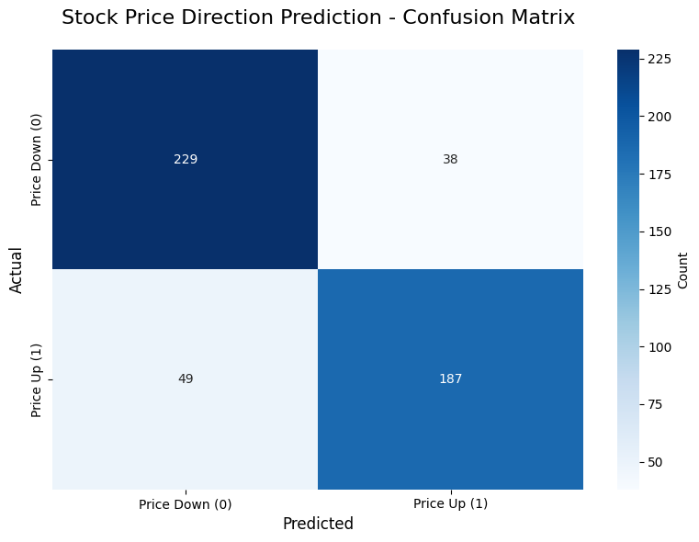

Confusion Matrix Breakdown:

True Negatives (TN): 229

False Positives (FP): 38

False Negatives (FN): 49

True Positives (TP): 187

Additional Metrics:

Precision: 0.8311

Recall (Sensitivity): 0.7924

Specificity: 0.8577

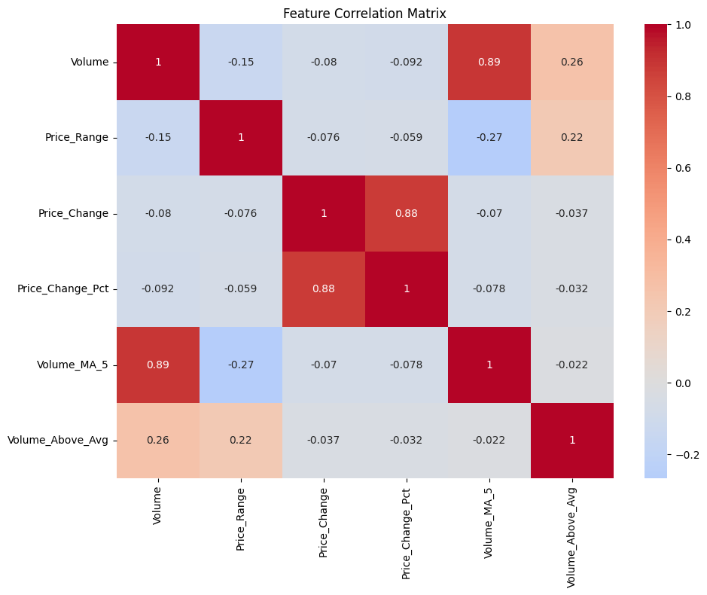

**RESULT**

Feature Importance:

feature coefficient abs_coefficient

3 Price_Change_Pct -2.001839 2.001839

2 Price_Change -0.936801 0.936801

1 Price_Range 0.377739 0.377739

0 Volume 0.054065 0.054065

5 Volume_Above_Avg -0.051708 0.051708

4 Volume_MA_5 -0.021862 0.021862

Sample Predictions:

Actual Predicted Probability

0 1 1 0.962132

1 1 1 0.761882

2 1 1 0.913239

3 1 1 0.623813

4 1 1 0.602739

5 0 0 0.308557

6 1 0 0.380055

7 1 1 0.729258

8 0 0 0.028868

9 1 1 0.979649